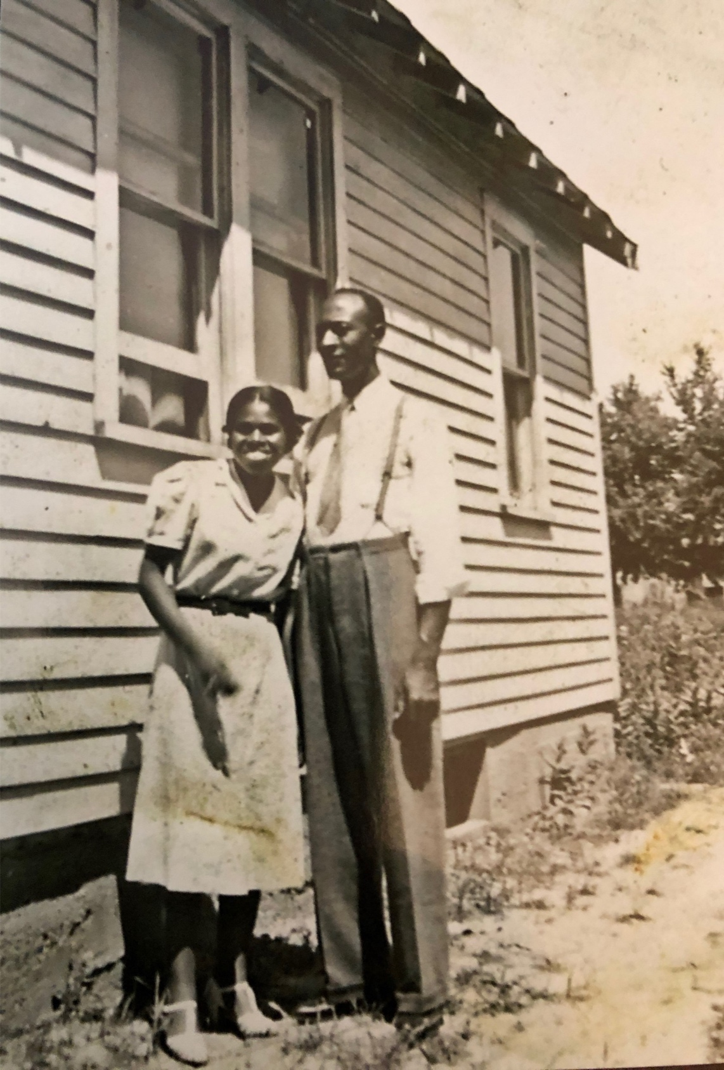

Iva G. and Evans B. Davis in front of their home in Flint, Michigan. Photograph. n.d. Davis Family Archives.

